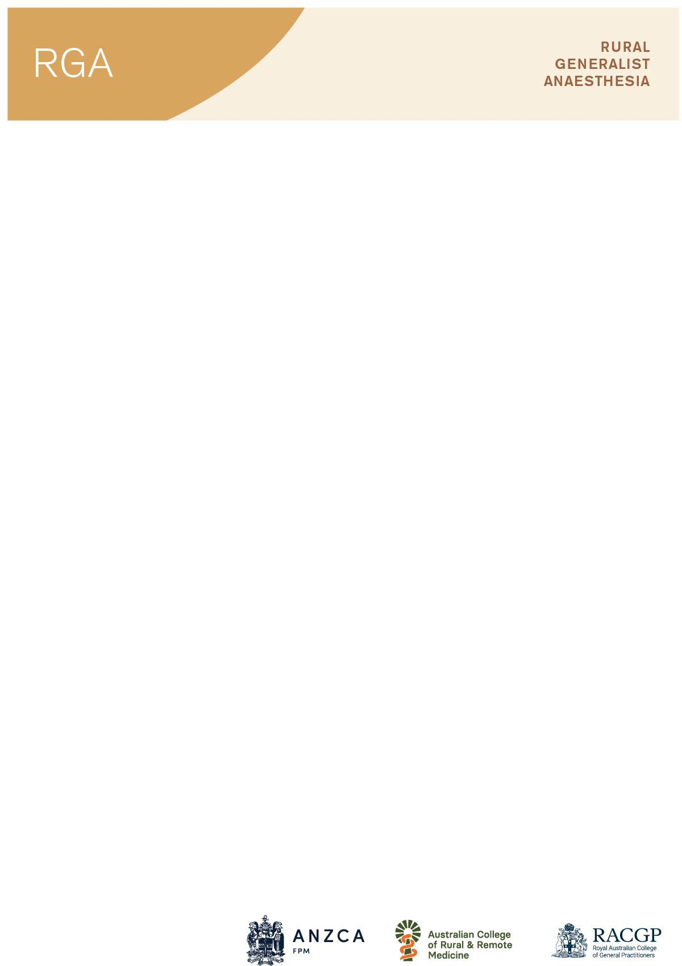

Rural Generalist Anaesthesia (RGA) training accreditation and re-accreditation – Application form

This application form is to be completed for the accreditation of Rural Generalist Anaesthesia (RGA) training site and its training supervisors.
The aim of an accredited site is to allow the GP registrar (and in some cases a fellow of a GP college) to further their knowledge and/or skills in anaesthesia. These posts are undertaken in a hospital setting.
This form is used to document the details of the training supervisors, both FANZCA and rural generalist anaesthetist, and the training opportunities available at that site. It is also used to document training opportunities and supervision at satellite sites and additional campus locations.

Before completing this form, please be familiar with the details of the training to be offered by reading the Rural Generalist Anaesthesia Program Curriculum and Regulation 44 – Training in rural generalist anaesthesia leading to RGA on ANZCA’s website.

Privacy statement
The details you have supplied will be used in the following manner:
- By the Australian and New Zealand College of Anaesthetists (ANZCA) to assess your application for accreditation, and in monitoring and evaluating the accreditation processes and its outcomes.
- Some parts of the RGA accreditation database may be shared with the colleges who are part of the tripartite committee – Australian and New Zealand College of Anaesthetists (ANZCA), The Royal Australian College of General Practitioners (RACGP) and the Australian College of Rural and Remote Medicine (ACRRM).
- The names of the RGA accredited hospitals may be included on the ANZCA, RACGP and ACRRM websites so that potential RGA trainees can contact a hospital directly to enquire regarding the availability of a training post.

Is your site currently accredited by ANZCA? ☐Yes ☐ No
Is this an application for re-accreditation of an accredited RGA training site? ☐Yes ☐ No Is this application to make changes to your current RGA accreditation? ☐Yes ☐ No

Contact us: rga-accreditation@anzca.edu.au

Address State Postcode Phone Email Date of application:
This application is for ☐ Full accreditation – 52 weeks FTE
(tick all that apply) ☐ Satellite campus accreditation – up to 26 weeks FTE
  - Additional campus accreditation – up to 4 weeks FTE

Applicant details
Name of the applicant Role of the applicant Email

Details of main (52 week) training site
Name of site Date of availability Proposed number of RGA training posts

Details of satellite training site (if applicable) – maximum 26 weeks FTE training time Name of site Date of availability

Details of additional campus (if applicable) – maximum 4 weeks FTE total training time Name of site Date of availability

Details of the Director of Medical Services/Delegate (main training site)
Full Name Phone Email

Details of the Head of Department (main training site)
Full Name Phone Email

Otherwise skip to section 3
2.1 Operating theatres
- Anaesthetic staffing (FTE)
  - RGA (FTE): Number of consultants to make up this FTE:
  - FANZCA (FTE): Number of consultants to make up this FTE:
  - SIMG (FTE): Number of consultants to make up this FTE:

- Number of trainees
  - ANZCA: Proposed RGA:
  - Other specialties (e.g.: ICU, ED, surgeons):
- Number of theatres:
- Number of lists (per week):
- Number of theatre cases (per category per year):
  - General surgery
  - Urological surgery
  - Gynaecological surgery
  - Ear, nose and throat surgery
  - Dental surgery
  - Obstetric anaesthesia & analgesia
    - Epidurals
    - Elective caesareans
    - Emergency caesareans
  - Ophthalmic surgery
  - Orthopaedic surgery
  - Plastic, reconstructive and burns surgery
  - Other
- Number of Paediatrics
  - Child 0 to <3 years
  - Child 3 to <5 years
  - Child 5 to <10 years
  - Child 10 to 16 years Recovery areas:
- Number of staffed recovery beds After hours:
- Average weekend and after hour theatre utilisation

Full Name Qualifications Address Postcode State Phone Email
Please include with your application:
- Copy of your curriculum vitae (signed and dated)

Signature Date
Electronic signature acceptable.

Rural GP Anaesthetist
Full Name Qualifications Address Postcode State Phone Email
Please include with your application:
- Copy of your curriculum vitae (signed and dated)

Signature Date
Electronic signature acceptable.

2.3 Educational Commitment
Does the hospital agree to develop (as required) and implement policies and procedures that ensure service requirements are compatible with the training requirements of the RGA? ☐ Yes ☐ No

Is the RGA State Support Officer aware of the accreditation application for your site? ☐ Yes ☐ No

Signature of the Director of Medical Services Date
Electronic signature acceptable.

This section is to be completed by the head of department and principal supervisor.

Supervisor name

How much teaching time will be allocated for the RGA each week? (Will it be rostered? On paid time? What form will it take?)

Topics that will be covered:

How will the RGA VOP requirements, especially for paediatric and obstetric cases be achieved? Minimum 30 paediatric cases (5-15yo). Minimum 30 obstetric epidurals after completion of EPA 2

Electronic signature acceptable.

Signature of the HOD Date
Electronic signature acceptable.

- Satellite RGA hospital accreditation details – up to 26 weeks FTE (if applicable)
  - Public Metro Hospital ☐ Co-located Private Hospital
Name of main training hospital
Contact person at main training hospital Role of contact person
Distance from parent hospital
How will the trainees be rotated between the two hospitals?
For example: 1 day per week, block rotations of x weeks, and to equal 26 weeks FTE training time.

Name of satellite hospital RGA Supervisor of training? Email How will in-training assessment (ITA), educational programs and other support be provided?
What training experience/Volume of practice will the trainee obtain by working at the satellite site?

- Additional campus accreditation (if applicable)
To be granted additional campus accreditation, the main ANZCA/RGA accredited training site must submit the application and confirm the following (tick box to confirm)
  - Maximum 4 weeks FTE training time
  - Confirmation of ACHS (Australia) or HealthCert (New Zealand) accreditation for the additional campus (Copy to be provided by email to rga-accreditation@anzca.edu.au)
  - On site supervision appropriate for the RGA trainee’s level of training is provided.
Supervisor name Email
  - That appropriate indemnity will be provided to trainees if required.

